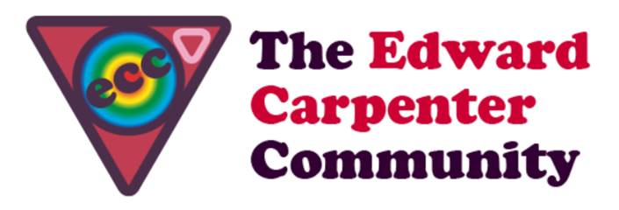
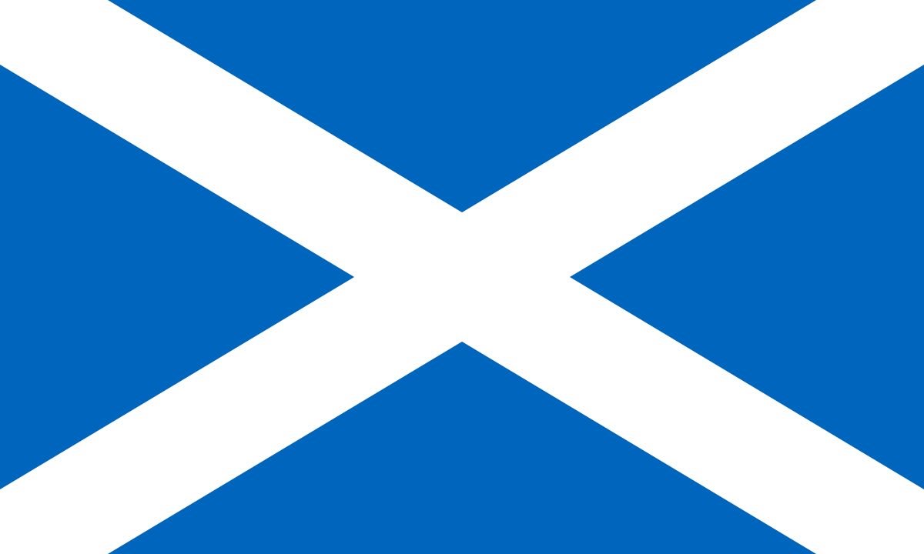
Edinburgh Fringe Meets Fife Countryside
11th -16th August 2019

ECC Scotland Invite you to The Edinburgh Festivals
Edinburgh hosts three festivals in August: The Fringe, the International Theatre Festival and the International Book Festival. There over 1000 performances per day: It’s the greatest show on Earth. Each one of them alone is enough to delight any gay man’s heart. This event is an opportunity to explore Edinburgh’s busy festivals in small groups. Daily lifts will be organised to Dunfermline from where there is a 30 min train connection to Edinburgh. Participants might choose and pre-book their festival favourites or go in for a lucky dip. Fun & tragedy, gay & colourful, socially engaged or light and fluffy: it is all there.
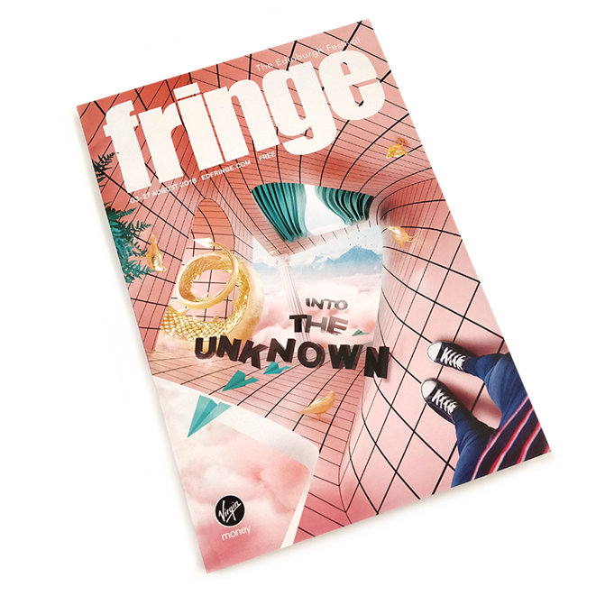
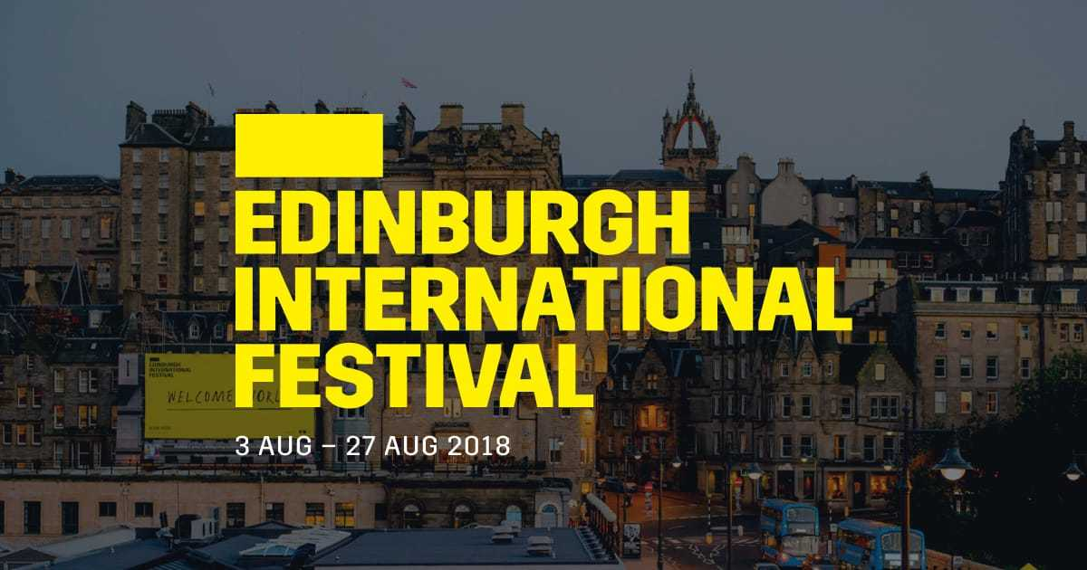

The trips to Edinburgh will be balanced with the opportunity to chill out together at the lodge in Fife’s green & pleasant land, go for walks along Rumbling Bridge & Loch Leven and share the experience of a day at the
theatres whilst sitting around the fire at Cherry Tree Lodge. Participants who have seen enough curtains going up, ballet shoes and heard Salmon Rushdie reading from his latest novel will happily take a day off, feeding gateau to the chickens or lie in the grass making daisy chains.
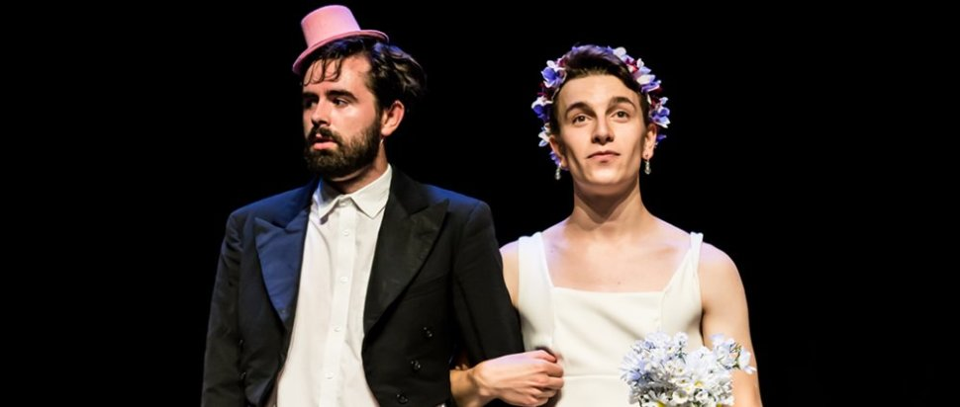

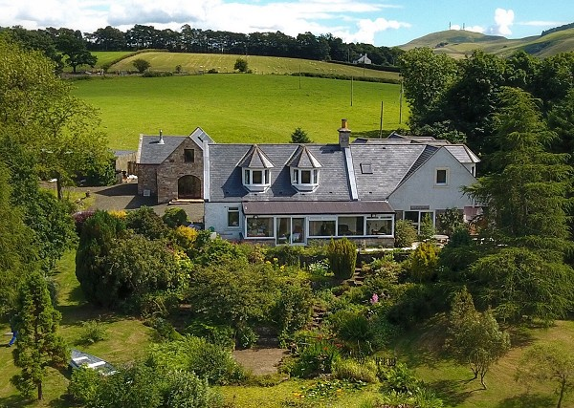
There will be a welcome dinner and opening circle Sunday evening. For the following days there will be a breakfast buffet and packed lunches (to eat in or out). To cater for men returning home at potentially different times there will be a hot soup on the stove with crusty home baked bread and cake awaiting them. On the last evening there will be a BBQ and closing circle.
Participants will be connected via whatsapp or e-mail as soon as they book the event. This will allow people to communicate about favourite shows and advanced booking. For Festival fanatics there is the option to extend their stay either before or after at preferential rates.

Start, finish & accommodation:
We will be up to 14 men. Arrival is from 4.30pm on Sunday 11th August and carriages are on Friday 16th after breakfast.
Accommodation is shared in light, airy and comfortable twin bed rooms. Single occupancy supplements are available.

Payment:
ECC Scotland follows the ECC guidelines to event pricing. Costs for accommodation and half board depend on income level and are listed below:
Income level | Cost (accomm. + HB)
High - £30k+ | £494
Average - £20K - £29,999 | £440
Low – up to £19,999 | £366 - breakeven
Concessionary rate (for people living at benefit levels) | £183
Bursary rate (for people who cannot afford the concessionary rate) | £92

You can reserve a place with your payment which includes a £80 non-returnable deposit over the phone with a debit card with Mark @ Cherry Tree Lodge on 01383 851059.

Cancellations: If you cancel up to 14 days before the start of the event your monies will be returned less the deposit which will go to the ECC Scotland bursary fund. If you cancel within 14 days you will receive a full refund if you find someone to take your place.

We are looking forward to festivalling with you – Till and Mark xx
