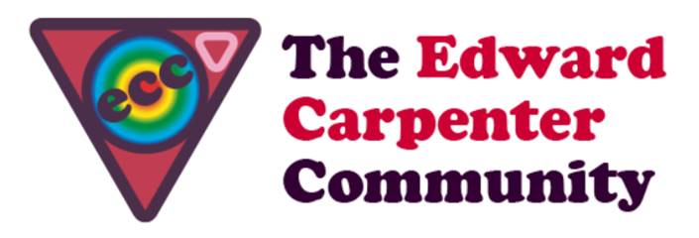
ECC Scotland Weekend
17th to 20th October 2019

Invitation to the annual ECC Scotland October Weekend
You are invited into this cosy bolt hole of togetherness, fun, friendliness and feasting @ Cherry Tree Lodge in Fife. What might we do this time round? - More workshops, walking, chatting, cooking, singing & dancing no doubt. Put the kettle on, put another log on the fire and put your feet up. Poor your soul out at a heart circle and let the process of intentional community do it’s magic.
For those who are new to ECC – “WELCOME”. The event has a basic spacious framework which is illustrated below. You might have an idea about sharing your talents, interests or facilitating a workshop. Let us know beforehand and we’ll support you in making it happen. We traditionally offer an hour per day either in the kitchen or around the house or on the land.
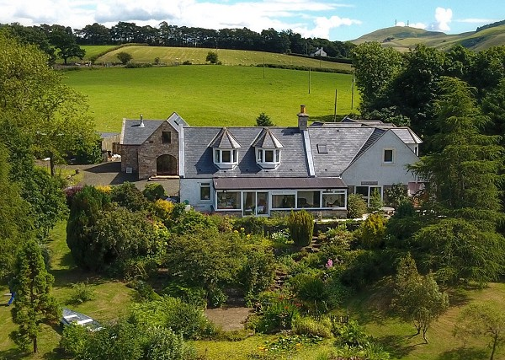
Activities for us to enjoy:
· Walk through the Fife countryside
· Movement Meditation of the Four Directions or Five Rhythms
· Tap into your creativity in the Art studio
· Big Screen showing of your favourite film
· Saturday singing session
· Preparing food and running the space together
. Background and tour of Cherry Tree Lodge [Mark & Till]
. A heart circle
…. other things!
· Or just chill out. You might want to join in it all or you might want to do your own thing at times.
Start, finish & accommodation:
We will be up to 14 men. Arrival is from 4.30pm on Thursday 17th October and carriages are on Sunday 20th after lunch at around 2pm.
Accommodation is shared in light, airy and comfortable twin bed rooms. Single occupancy supplements are available.

Payment:
ECC Scotland follows the ECC guidelines to event pricing. Costs for accommodation and half board depend on income level and are listed below:
Income level | Cost (accomm. + HB)
High - £30k+ | £274
Average - £20K - £29,999 | £244
Low – up to £19,999 | £203 - breakeven
Concessionary rate (for people living at benefit levels) | £101
Bursary rate (for people who cannot afford the concessionary rate) | £51

You can reserve a place with your payment which includes a £40 non-returnable deposit over the phone with a debit card with Mark @ Cherry Tree Lodge on 01383 851059.

Cancellations: If you cancel up to 14 days before the start of the event your monies will be returned less the deposit which will go to the ECC Scotland bursary fund. If you cancel within 14 days you will receive a full refund if you find someone to take your place.

We are looking forward to our weekend together – Till and Mark xx

