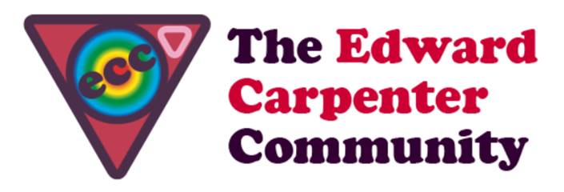
ECC Scotland Walking Week
3rd to 10th May 2019

You are invited to a walking week in the heart of Scotland

In May Scotland is at its best – and this is your opportunity to explore some highlights with a group of up to 14 ECC men. Following a successful week in 2018 the following provisional programme (dependant on weather and needs of the group) is offered with a good mix of walking, sight-seeing and spending time together at Cherry Tree Lodge in Fife as the base. Alternative routes will accommodate different levels of walking skills.
Friday 4th | Arrival at Cherry Tree Lodge from 5pm, dinner & opening circle in the evening
Saturday 5th | From Cherry Tree Lodge through West Fife to the Royal Borough of Dunfermline
Sunday 6th | Further along the Fife Coastal Path: Anstruther, Crail & beyond
Monday 7th | Edinburgh or Glasgow – that is the question.
Tuesday 8th | Hiking along the top of the Ochills & story telling evening
Wednesday 9th | Perthshire: Kinnoull Hill & down to the Tay with opportunity to visit the new V&A Dundee
Thursday 10th | Hiking in the Scottish Highlands & dinner
Friday 11th | Closing circle & Departure

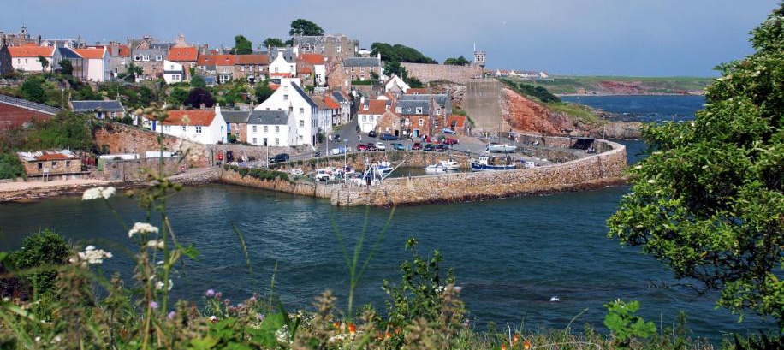

Cherry Tree Lodge is located in the scenic ‘Paradise of Fife’ and will be your home offering a cosy atmosphere and is surrounded by nature. Getting to the various destinations will require some car sharing, bus ride or hiring with costs spread across the group during the week. Catering by Mark is half board starting with a hearty breakfast and either a packed lunch or dinner. As in the Laurieston tradition everybody contributes a bit to running the household. The 3rd meal of the day will be purchased whilst out and about. Till will be the guide on four of the six days. The evening will be relaxing, sharing, playing games, tapping the creative impulse in the art studio, listening to Beverley (a professional story teller) or watching a film cinema style.
Start, finish & accommodation:
We will be up to 14 men. Arrival is from 4.30pm on Friday 3rd May and carriages are on Friday 10th after breakfast.
Accommodation is shared in light, airy and comfortable twin bed rooms. Single occupancy supplements are available.

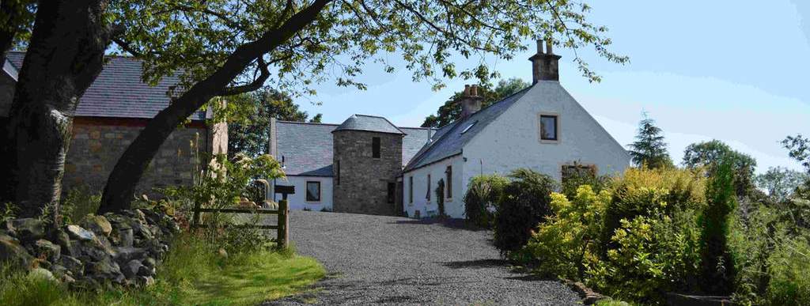

Payment:
ECC Scotland follows the ECC guidelines to event pricing. Costs for accommodation and half board depend on income level and are listed below:
Income level | Cost (accomm. + HB)
High - £30k+ | £685
Average - £20K - £29,999 | £610
Low – up to £19,999 | £507.50 - breakeven
Concessionary rate (for people living at benefit levels) | £254
Bursary rate (for people who cannot afford the concessionary rate) | £127

Other costs to bear in mind are:
- Transport - Getting to the various destinations will require some car sharing or hiring with costs spread across the group – approx. £60 per person. (includes bus fares/ Car sharing / car rental / petrol & insurance)
- Travel insurance – to be organised by yourself
- Additional meals to those included – from Shops, snack bars, cafés or pubs en-route.

Minimum number of participants is 5 including at least one driver.

You can reserve a place with your payment which includes a £100 non-returnable deposit over the phone with a debit card with Mark @ Cherry Tree Lodge on 01383 851059 or 07940 421038.

Cancellations: If you cancel up to 14 days before the start of the event your monies will be returned less the deposit which will go to the ECC Scotland bursary fund. If you cancel within 14 days you will receive a full refund if you find someone to take your place.

For more info about Cherry Tree Lodge see www.cherrytreelodge.net.

For any questions about the programme please contact Till. markandtill@cherrytreelodge.net or call 00447834596727.

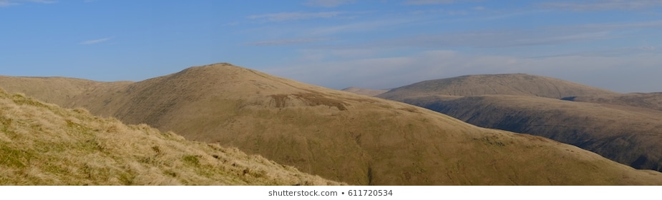

We are looking forward to welcoming you (back) to a walking week in bonnie Scotland – Till and Mark xx

